Sami Eljabali
Stat133-BQ
HW5
Text mining the State of the Union Speeches

Explore the speeches:
Compare the number of sentences in each speech, the average number of words in a sentence, the total number of words in the speech, and any other numerical summary of the speech.

-Does any president stand out? Do presidents from the same era give similar speeches?

Yes, James Madison in particular has the highest number of words per sentence among all presidents. Here’s a list of presidents with the highest word per sentence.

1) James Madison ~ 50.22222
2) Martin van Buren ~ 49.12022
3) James Madison ~ 47.60417
4) James Madison ~ 46.26027
5) James Madison ~ 45.38889

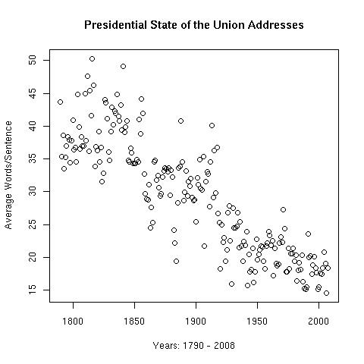
Here’s a plot of presidents and their average words per sentence. As we can easily see, there’s a decrease in the number of words per sentence.

Also if we saw what Washington said.
> Washington = combineSpeechesAndStem(speeches,c(1:8))
> w = table(Washington)
We’d see that the word “tribe” had been used 12 times.

And if we were to compare that to Bush, we see that he mentioned the word “terrorist” more than 100 times.

Here we can see emphasis on the American enemy, Native Indians back in the day, be less stressed. Whereas now, we see a hard attempt to make Americans scared of its enemy.

